Name: __________________________________

Google Docs Portfolio
History of Fashion Portfolio Pages

Make sure that when using Google images that you type in the year and the bolded word/fashion.
Example: 1890 Corset

1890’s – Historical influence= Victorian Era.
Women: Gibson Girl, corset, bustle, hourglass silhouette.
Men – matching coat and vest with contrasting trousers.

1900’s – Historical influence= Industrial Revolution Era.
Women: Duster coat, shirtwaist, Leg O’ Mutton sleeves, s-curve silhouette.
Men – formal morning dress with top hats, or 3-piece ‘lounge’ suits with bowler hats
1910’s - WWI Era.
Women -Hobble skirt, bathing suit, bloomers, inverted triangle silhouette.
Men – military influence/trench coats

1920’s – Historical influence= “Roaring ‘20’s” Era,
Women: flapper, costume jewelry, cloche’ hat, dropped waistlines,
tubular silhouette;
Men: pin-stripe suits, fedoras, sweaters, knickers, raccoon coat

1930’s – Historical influence=Depression Era,
Women: bias cut dresses, waistline restored, hemlines dropped, hourglass silhouette
Men: straight wide leg trousers, sweater vests;
Children: hand-me downs, flour sack clothing

1940s – Historical influence=WWII Era
Women: convertible suit(mix and match pieces), slacks, no silk or nylon stockings, inverted triangle silhouette.
Eisenhower jacket inverted triangle silhouette;
Men: Military influence/bomber jacket, austere “Victory’ suits with no vest, cuff or pocket flaps

1950s – Historical influence= Rock n’ Roll Era,
Women: the ‘new look’ hourglass silhouette (Christian Dior) hourglass silhouette
Men: Flannel suit in charcoal gray, navy or brown, cardigan sweaters, hats;
Teenager: a separate generation;
Girls: poodle skirts, sweater sets, saddle shoes, capri pants; teenagers become their own class and have money to spend,
Boys: chinos, button down shirts, loafers OR tight jeans, t-shirts, leather jackets, Converse

1960s – Historical influence =Civil rights Era
Women: Miniskirts, pantsuits, pillbox hat, tubular silhouette.
Men – tailored suits, the ‘Mod’ look, turtlenecks, colors

1970s – Historical influence =Hippy to Dicso Era, Energy Crisis, Watergate,
Women: Unisex, bold flower prints, platform shoes, triangle silhouette.
Men – bell bottoms, wide ties and collars

1980s – Historical influence = YUPPIE Era
Women: Logo wear, designer jeans, exercise wear, inverted triangle silhouette.
Men – business suits with narrow detailing, suspenders, pastels

1990s – Historical influence = The Dot Com Era
Women: Bare midriff, rejection of fashion, grunge.
Men – baggy pants, big sneakers

2000s - Inspiration drawn from the previous decades anything goes! The web makes all information easily accessible and fashion crossover common.

History of Fashion Notes

Decade
__________________________________________________________________

Historical Events
________________________________________________________________________________________________________________________________________________________________________________________________________________________________________________________________________

Women’s Fashion
_______________________________________________________________________________________________________________________________________________________________________________________________________________________________________________________________________________________________________________________________________________

Men’s Fashion
____________________________________________________________________________________________________________________________________________________________________________________________________________________________________________________________________________
Silhouette
___________________________________________________________________

Other
_______________________________________________________________________________________________________________________________________________________________________________________________________________________________________

History of Fashion Notes

Decade
__________________________________________________________________

Historical Events
________________________________________________________________________________________________________________________________________________________________________________________________________________________________________________________________________

Women’s Fashion
_______________________________________________________________________________________________________________________________________________________________________________________________________________________________________________________________________________________________________________________________________________

Men’s Fashion
____________________________________________________________________________________________________________________________________________________________________________________________________________________________________________________________________________
Silhouette
___________________________________________________________________

Other
_______________________________________________________________________________________________________________________________________________________________________________________________________________________________________

History of Fashion Notes

Decade
__________________________________________________________________

Historical Events
________________________________________________________________________________________________________________________________________________________________________________________________________________________________________________________________________

Women’s Fashion
_______________________________________________________________________________________________________________________________________________________________________________________________________________________________________________________________________________________________________________________________________________

Men’s Fashion
____________________________________________________________________________________________________________________________________________________________________________________________________________________________________________________________________________
Silhouette
___________________________________________________________________

Other
_______________________________________________________________________________________________________________________________________________________________________________________________________________________________________

History of Fashion Notes

Decade
__________________________________________________________________

Historical Events
________________________________________________________________________________________________________________________________________________________________________________________________________________________________________________________________________

Women’s Fashion
_______________________________________________________________________________________________________________________________________________________________________________________________________________________________________________________________________________________________________________________________________________

Men’s Fashion
____________________________________________________________________________________________________________________________________________________________________________________________________________________________________________________________________________
Silhouette
___________________________________________________________________

Other
_______________________________________________________________________________________________________________________________________________________________________________________________________________________________________

History of Fashion Notes

Decade
__________________________________________________________________

Historical Events
________________________________________________________________________________________________________________________________________________________________________________________________________________________________________________________________________

Women’s Fashion
_______________________________________________________________________________________________________________________________________________________________________________________________________________________________________________________________________________________________________________________________________________

Men’s Fashion
____________________________________________________________________________________________________________________________________________________________________________________________________________________________________________________________________________
Silhouette
___________________________________________________________________

Other
_______________________________________________________________________________________________________________________________________________________________________________________________________________________________________

History of Fashion Notes

Decade
__________________________________________________________________

Historical Events
________________________________________________________________________________________________________________________________________________________________________________________________________________________________________________________________________

Women’s Fashion
_______________________________________________________________________________________________________________________________________________________________________________________________________________________________________________________________________________________________________________________________________________

Men’s Fashion
____________________________________________________________________________________________________________________________________________________________________________________________________________________________________________________________________________
Silhouette
___________________________________________________________________

Other
_______________________________________________________________________________________________________________________________________________________________________________________________________________________________________

History of Fashion Notes

Decade
__________________________________________________________________

Historical Events
________________________________________________________________________________________________________________________________________________________________________________________________________________________________________________________________________

Women’s Fashion
_______________________________________________________________________________________________________________________________________________________________________________________________________________________________________________________________________________________________________________________________________________

Men’s Fashion
____________________________________________________________________________________________________________________________________________________________________________________________________________________________________________________________________________
Silhouette
___________________________________________________________________

Other
_______________________________________________________________________________________________________________________________________________________________________________________________________________________________________

History of Fashion Notes

Decade
__________________________________________________________________

Historical Events
________________________________________________________________________________________________________________________________________________________________________________________________________________________________________________________________________

Women’s Fashion
_______________________________________________________________________________________________________________________________________________________________________________________________________________________________________________________________________________________________________________________________________________

Men’s Fashion
____________________________________________________________________________________________________________________________________________________________________________________________________________________________________________________________________________
Silhouette
___________________________________________________________________

Other
_______________________________________________________________________________________________________________________________________________________________________________________________________________________________________

History of Fashion Notes

Decade
__________________________________________________________________

Historical Events
________________________________________________________________________________________________________________________________________________________________________________________________________________________________________________________________________

Women’s Fashion
_______________________________________________________________________________________________________________________________________________________________________________________________________________________________________________________________________________________________________________________________________________

Men’s Fashion
____________________________________________________________________________________________________________________________________________________________________________________________________________________________________________________________________________
Silhouette
___________________________________________________________________

Other
_______________________________________________________________________________________________________________________________________________________________________________________________________________________________________

History of Fashion Notes

Decade
__________________________________________________________________

Historical Events
________________________________________________________________________________________________________________________________________________________________________________________________________________________________________________________________________

Women’s Fashion
_______________________________________________________________________________________________________________________________________________________________________________________________________________________________________________________________________________________________________________________________________________

Men’s Fashion
____________________________________________________________________________________________________________________________________________________________________________________________________________________________________________________________________________
Silhouette
___________________________________________________________________

Other
_______________________________________________________________________________________________________________________________________________________________________________________________________________________________________

History of Fashion Notes

Decade
__________________________________________________________________

Historical Events
________________________________________________________________________________________________________________________________________________________________________________________________________________________________________________________________________

Women’s Fashion
_______________________________________________________________________________________________________________________________________________________________________________________________________________________________________________________________________________________________________________________________________________

Men’s Fashion
____________________________________________________________________________________________________________________________________________________________________________________________________________________________________________________________________________
Silhouette
___________________________________________________________________

Other
_______________________________________________________________________________________________________________________________________________________________________________________________________________________________________

History of Fashion Notes

Decade
__________________________________________________________________

Historical Events
________________________________________________________________________________________________________________________________________________________________________________________________________________________________________________________________________

Women’s Fashion
_______________________________________________________________________________________________________________________________________________________________________________________________________________________________________________________________________________________________________________________________________________

Men’s Fashion
____________________________________________________________________________________________________________________________________________________________________________________________________________________________________________________________________________
Silhouette
___________________________________________________________________

Other
_______________________________________________________________________________________________________________________________________________________________________________________________________________________________________

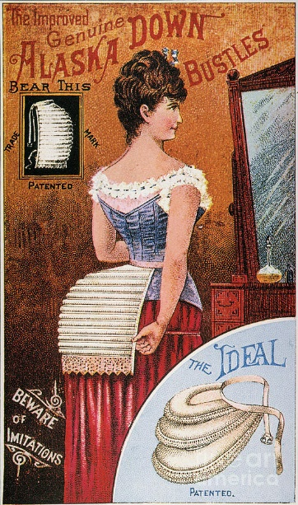
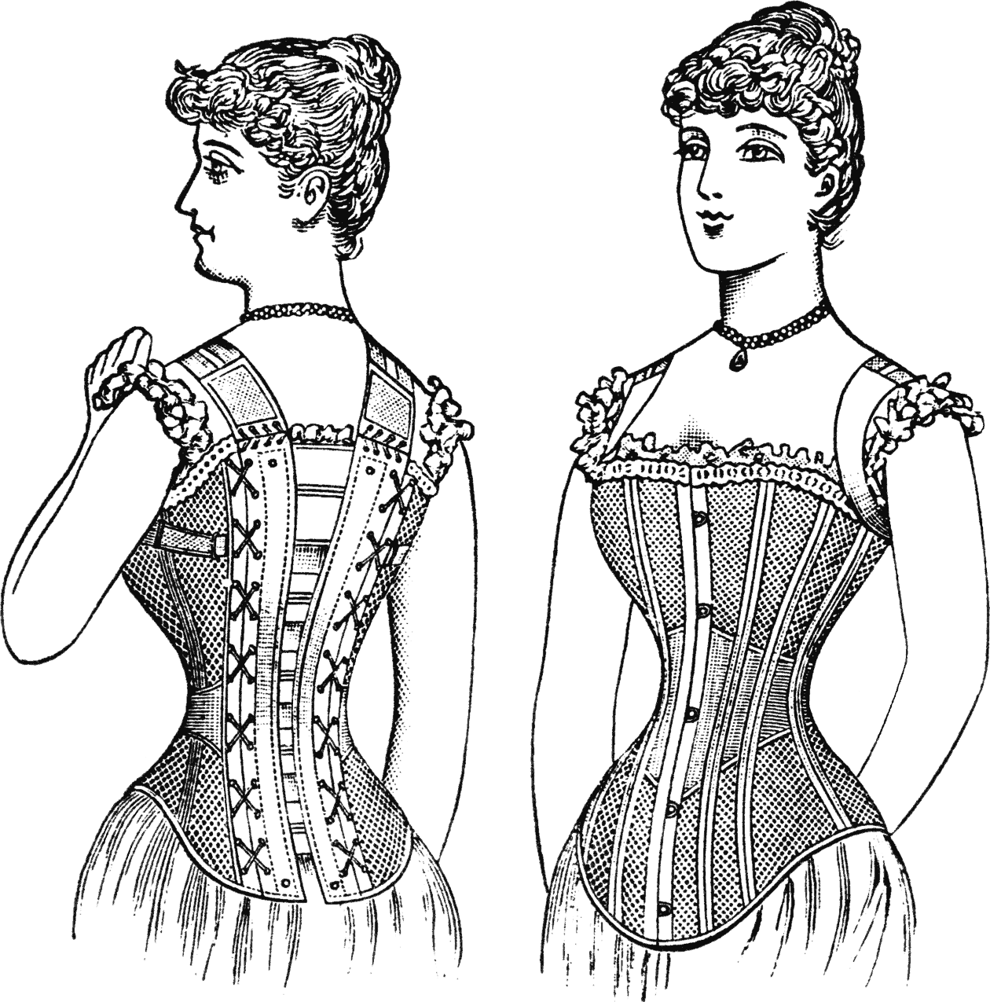
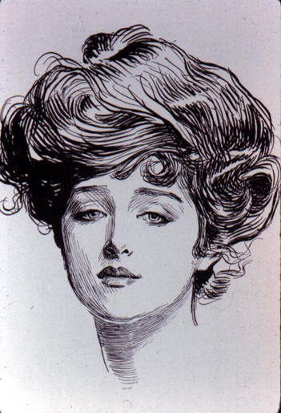
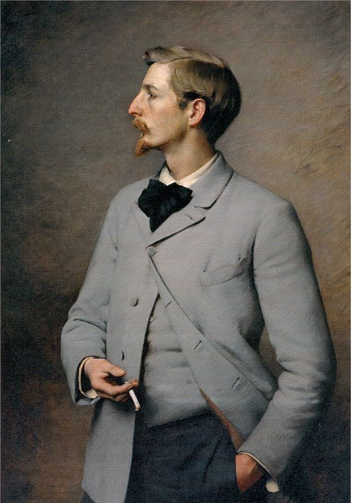
Matching vest with contrasting trousers
Gibson Girl
Hourglass Silhouette

Descriptive Paragraph using all bolded words.
The 1890’s was the Victorian Era, because Queen Victoria was ruler. The Ideal Woman in America and Great Britain was the Gibson Girl. The silhouette of that decade was an hourglass. Sometimes a very exaggerated hourglass because of the tightly cinched corset and the full bustle on the backside. The hourglasss silhouette was the style of its day for women. During this decade men wore matching coat and vests with contrasting trousers.

Bustle
Corset
Photo Examples of bolded words:

Gibson Girl,

Victorian Era

1890’s
decade
Matching coat and vest with contrasting trousers
Gibson Girl
bustle

