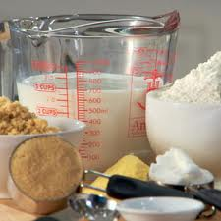
Oatmeal Chocolate Chip Cookies
- ½ cup margarine
- ½ cup brown sugar
- ½ cup white sugar
- 1 egg
- ½ tsp. vanilla
- 1 cup flour +1/4 cup flour
- ½ tsp. baking powder
- ½ tsp. baking soda
- ¼ tsp. salt
- 1 cup oatmeal
- ½ cup chocolate chips

Directions
Mix first five ingredients. Add remaining ingredients. Roll dough into small balls and bake at 350 degrees for 8 to 10 minutes.
LAB EVALUATION
- How many seconds do you wash your hands before preparing food? ________ seconds
- List the four sizes of measuring spoons and place them in order biggest to smallest.
______ _______ ______ ______
- List the four sizes of the dry measuring cups and place them in order biggest to smallest.
______ _______ ______ ______
- What order should you wash dishes
_____Silverware
_____Pots and Pans
_____Dishes
_____Glasses
- How many cups are in a cube of butter?
Microwave Bubble Bread

- 1/3 cup brown sugar
- 3 T margarine
- 1 T water
- 1 can refrigerated biscuits

Directions

- Using the pizza cutter, cut each of the biscuits into fourths
- In the round casserole dish, combine brown sugar, margarine and water. Microwave on high for 1 minutes.
- Place the biscuits on top of the melted brown sugar mixture
- Microwave on high for 2 minutes (not sticky)
- THE DISH WILL BE HOT –USE HOT PAD
- To serve: Place a large serving plate on top of the round casserole dish and turn upside down until the bread comes out.
- Pull apart with fingers

LAB EVALUATION

- What is the proper piece equipment to measure milk?

- What piece of equipment would you use to cut-in?

- What two ingredients do you use to cream?
1.
2.
4. What piece of equipment would you use to dice, mince, and chop?

5.To sauté you cook in a little amount of _____________.

- What is the abbreviations for the following?
Package__________________ Tablespoon___________________
Quart____________________ Ounce______________________
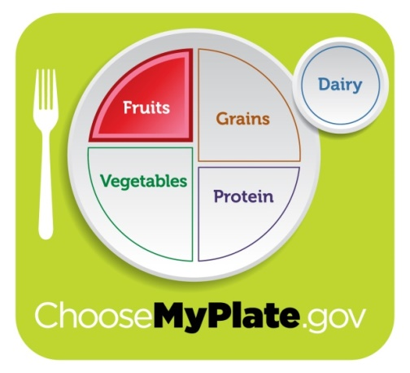
100% Fruit Banana Spilt Smoothie

- 1 ¼ cup 100% orange juice
- 1 cup frozen strawberries
- ½ Can of canned pineapple
- 1 banana

Directions

Pour orange juice into the blender and add frozen fruit. Push the smoothie button. If large chunks of fruit are still in the smoothie use the pulse button or the smoothie button again.
Serve and enjoy!

LAB EVALUATION
- Why should you buy fruits in season?

- Fruit juice only counts as a serving of fruit if it is ______% _______.

- By eating fruit it can prevent someone from getting 5 chronic diseases. List 3 of the 5 diseases.
- 2. 3.

- Fruits are high in what 3 nutrients?
- 2. 3.

- Half the following the ingredients:
1 ½ cup flour __________________________
¼ cup sugar __________________________
½ tsp salt ____________________________
2 cups milk______________________________

- What does knead mean?

Even Groups= Jalapeno Cheese Corn Muffins

Odd Groups= Delish Corn Muffins

Jalapeno Cheese Corn Muffins

- 1 jalapeno
- 1/3 cup sugar
- 1 Tbsp. honey
- 1/4 cup melted butter
- 1 large egg
- 1/4 tsp. baking soda
- 1/2 cup buttermilk
- 1/4 tsp. salt
- 1/2 cup yellow cornmeal
- 1/2 cup flour
- 1/4 cup shredded cheddar cheese

DIRECTIONS:
- Preheat the oven to 375 degrees. Remove the seeds from and slice jalapeno finely. Set aside.
- In a medium bowl, stir sugar, honey and butter together. Whisk in egg. Whisk in baking soda and buttermilk.
- Add salt, cornmeal, and flour. Do not over-mix. As soon as the flour disappears, stop mixing.
- Fold in sliced jalapeno and shredded cheddar cheese.
- Add batter equally to the cups of a greased or lined muffin tin, MAKE 10 MUFFINS.
- Bake for 15-20 minutes.
DE-Lish Corn Bread

- 1/3 C Flour
- 1/4 C yellow cornmeal
- 1 1/3 C yellow cake mix
- 2 T sugar
- 1 ½ tsp. baking powder
- ¼ tsp salt
- 3 T C Vegetable oil
- 1 eggs
- ½ C. milk
1. Combine all dry ingredients in a mixing bowl. Mix well.
2. In a separate mixing bowl combine oil, milk and eggs. Add all wet ingredients to the dry ingredients and mix until batter is smooth.
3. Spoon mix into a greased muffin tin, filling each one about 1/2 full MAKE 10 Muffins.
4. Bake 350 degrees for 15-20 minutes.

LAB EVALUATION
- List 4 examples of whole grains

- What are refined grains?

- List 3 examples of refined grains?

- What is the key consumer message for grains?

- List three nutrients you get when eating grains?

- List two ways you could increase whole grains in your diet?

- What does it mean on a label if it say enriched?

- Grains contain carbohydrates which gives your body _____________.

Italian Cheese Bread

Dough Ingredients
- 2 ½ c. flour
- 1 tsp. salt
- 1 tsp. sugar
- 1 T yeast
- 1 c. warm water
- 1 T vegetable oil

Topping Ingredients
- ¼ c. Italian salad dressing
- ¼ tsp. salt
- ¼ tsp garlic powder
- ½ tsp. Italian seasoning
- 1 T grated parmesan cheese
- 1 slice mozzarella cheese

- Preheat oven to 450 º.
- In the 2 cup liquid measuring cup mix warm water and yeast and 1 T sugar. Stir ingredients and allow to sit until yeast is activated.
- Place flour and salt into Bosch mixing bowl mix on setting 1.
- Add oil to active yeast mixture.
- With the lid on the Bosch mixer, gradually add liquid mixture to dry ingredients on setting 2.
- Once dough pulls from the side of the bowl to form a ball turn up Bosch to setting 3 and “knead” for 3 minutes. Watch closely mixer will be rockin’.
- Let rise in a warm place for 15 minutes.
- After rising, punch the dough down and place on a greased pizza pan. Push the dough out until it forms a thin circle. (It will look like pizza dough.)
- With a pastry brush, brush the top of the dough with the Italian salad dressing. Then sprinkle with the rest of the topping ingredients in this order: salt, garlic powder, Italian seasoning, parmesan cheese, and mozzarella cheese.
- Place in the oven and bake for 15 minutes or until golden brown. Remove from oven, cut with a pizza cutter and serve warm.

Parmesan Potato Soup

1st Step = Job #1
- ¼ tsp. dried basil
- ¼ tsp. salt
- 1/8 tsp. celery salt
- 1/8 tsp. garlic powder
- 1/8 tsp. onion salt
- 1/8 tsp. pepper
- 1/8 tsp. sage
- 1/8 tsp. dried thyme

2nd Step = Job #2
- 3 medium baking potatoes
- ½ onion chopped professionally
- ½ c. margarine

3rd Step= Job #3
- 1 c. chicken broth (1 bouillon cube or 1 tsp powder)
- ½ cup flour
- 2 c. milk
4 Step= Job #4
- ¼ c. grated fresh parmesan cheese
- 3 bacon strip cooked and dice

1. Pierced potatoes with a fork; bake in the microwave until tender. Cool, peel and cube; set aside.
2. In a saucepan, over medium heat, sauté onion in butter until tender.
3. Stir in flour and seasoning (this makes the roux).
4. In a liquid measuring cup add 1 cup water to 1 tsp bouillon (or 1 cube) microwave for 1 minute.
5. Gradually add broth and milk, stirring constantly with a whisk. Bring to a boil.
6. Add potatoes and cheese, heat through. Stir in cooked bacon.
LAB EVALUATIONS
- What is the key consumer message for the dairy group?

- The major health benefit of dairy product is?

- What years are especially important to have adequate dairy?

- Milk is the most _________________________drink you can drink.

- List two foods that are not considered part of the dairy group because they have a high content of fat.

- Besides calcium what two other vitamins do you get from milk?

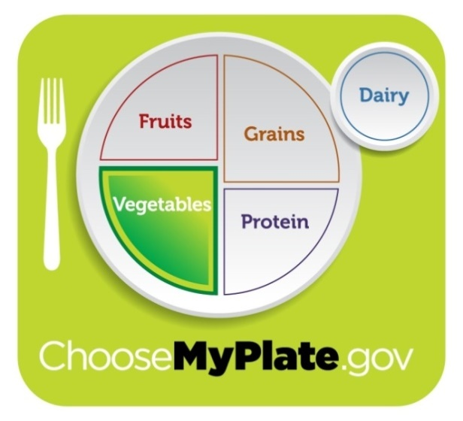
Baked Zucchini Fries
- 1/4 cup flour
- ½ cup Italian seasoned panko bread crumbs
- ¼ cup grated Parmesan cheese
- 2 eggs
- 2 zucchini
- 1/3 cup ranch dressing for dipping

Directions:
- Preheat oven to 425© F. Line a baking sheet with aluminum foil and spray with nonstick cooking spray. Set aside
- Cut into zucchini into batonett (1/4 inch ¼ inch)
- Place flour in a cereal bowl and set aside. Combine bread crumbs and parmesan cheese in a cereal bowl and set aside. Whisk 2 eggs together in a bowl and set aside.
- Working with a small handful of strips at a time, DREDGE zucchini in flour and shake to remove any excess. Dip in egg, shake to remove any excess, and then roll in about 2-3 Tablespoons of bread crumbs at a time, adding more as needed. Don’t work with all the bread crumbs at once because they’ll soak up moisture from the egg and wont’ stick to the zucchini. Place coated strips on the prepared baking sheet and repeat until all the zucchini strips have been coated.
- Bake 10-12 minutes. Remove from oven, flip the fries, and bake another 5 minutes or until zucchini is not soggy and the coating is crisp and golden brown.
- Serve with ranch dressing.
Lab Evaluation
- Vegetables contain no added ____________ or ___________________.
- Vegetables are very HIGH in what two nutrients?_______________ and ________
- What color of vegetables have more nutrients?
- What color of vegetable have not as many nutrients?
- How should you hold your non-cutting hand when cutting zucchini fries

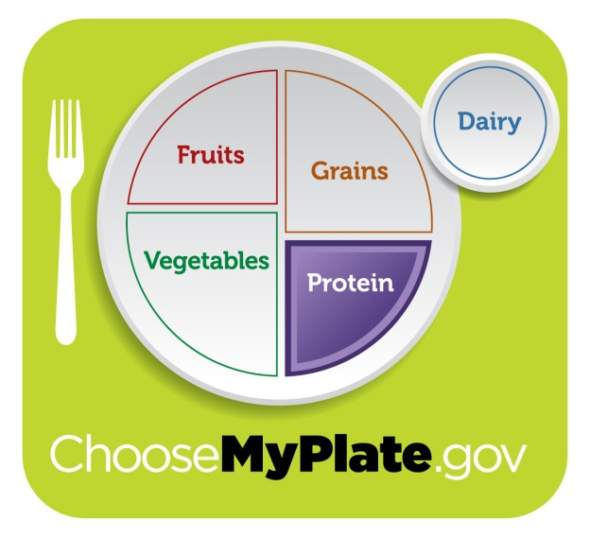
Quinoa Cups
- 1 cup cooked quinoa
- 1 egg
- 1 egg white
- ¼ cup grated zucchini
- 1 block of cheese grated
- 2 slices of ham diced
- 2 sprigs of parsley minced
- 1 T Parmesan cheese
- 1 green onion
- ¼ tsp salt
- ¼ tsp pepper

Directions:
- Place a nonstick mini muffin pan in the oven and heat to 400©F.
- Add all ingredients to a large bowl and mix to combine.
- Carefully remove the pan from the oven (don’t forget it’s hot!) and quickly spray the wells with nonstick spray. Fill muffin wells ¾ full with batter.
- Bake 15-20 minutes or until the edges of the cups are golden brown.
- Let cool for at least 5 minutes in the tin before eating.
LAB EVALUATION
- Protein foods can from what two sources?

- What’s the key consumer message for protein?

- Circle all the protein foods:
Kidney beans chicken breast slice of bread pork chop
Salmon eggs almonds oatmeal hamburger
Sticky Chicken Over Brown & White Rice

- ¼ cup cornstarch
- ½ cup Kraft Russian salad dressing
- ¼ cup apricot jam
- 1 chicken breast
- 2 T oil

Directions:
Cut chicken breast into 1 inch squares, dredge into cornstarch, and place 2 T oil and chicken into a skillet. Lightly brown the chicken then place in the glass square pan. In a mixing bowl place Russian dressing and apricot jam and mix together. Pour mixture over the lightly brown chicken and mix until all chicken is covered. Bake at 350© F for 15 minutes.
Rice
- ½ cup rice
- 1 ½ cup water

Directions:
In a saucepan place rice and water bring to boil. Only stir 3 times to combine water and rice. Boil for 3 minutes cover and simmer for 10-12 minutes until water is absorbed.

Brown Rice
- ½ cup cooked brown rice
Combine white and brown rice place on one serving size on each plate then top with sticky chicken
Lab Evaluation
- Which rice is better for you? Explain your answer

- List 3 ways of choosing or cooking lean meats
1. 2. 3.
3.. List 3 ways to vary your protein choices.
1. 2. 3.
Name:
Recipe Book

8th Grade FACS
Exploration

Name:

Foods I

RECIPE BOOK

